***Calculating Family Expenses Using Servicenow***

Setting Up Servicenow Instance:

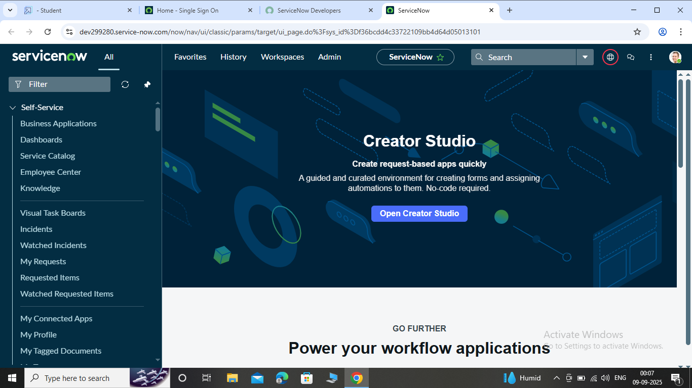

Creation of New Update Set:

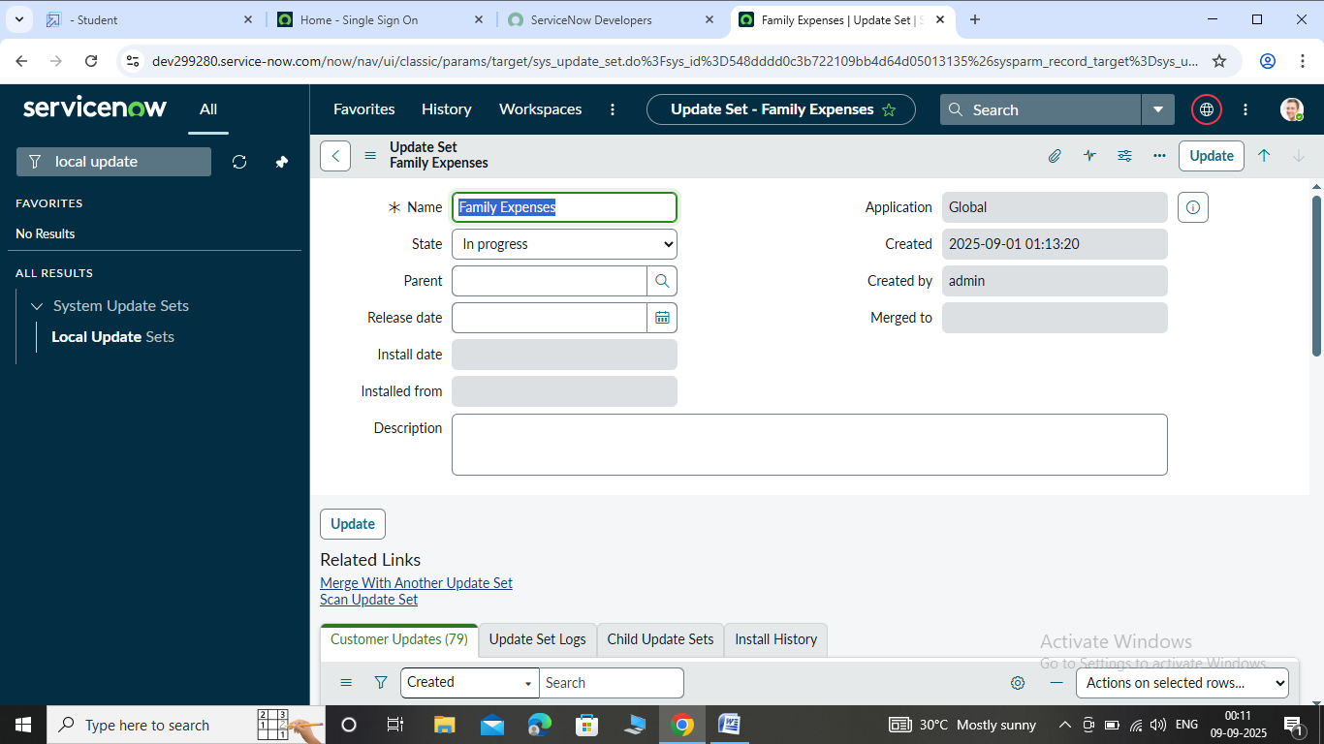

**Family Expenses Table:**

Creation of Family Expenses Table:

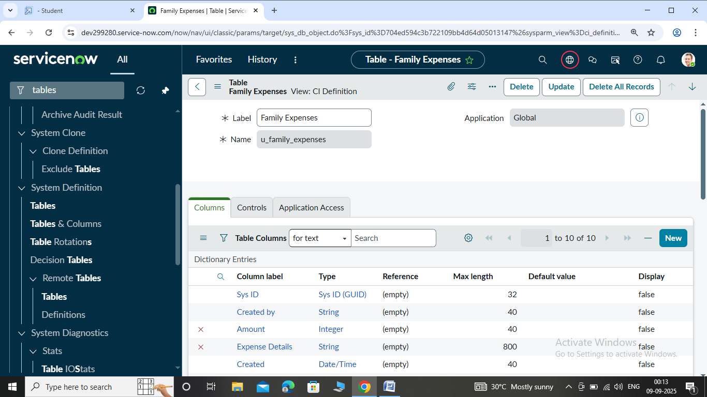

Creation of Columns:

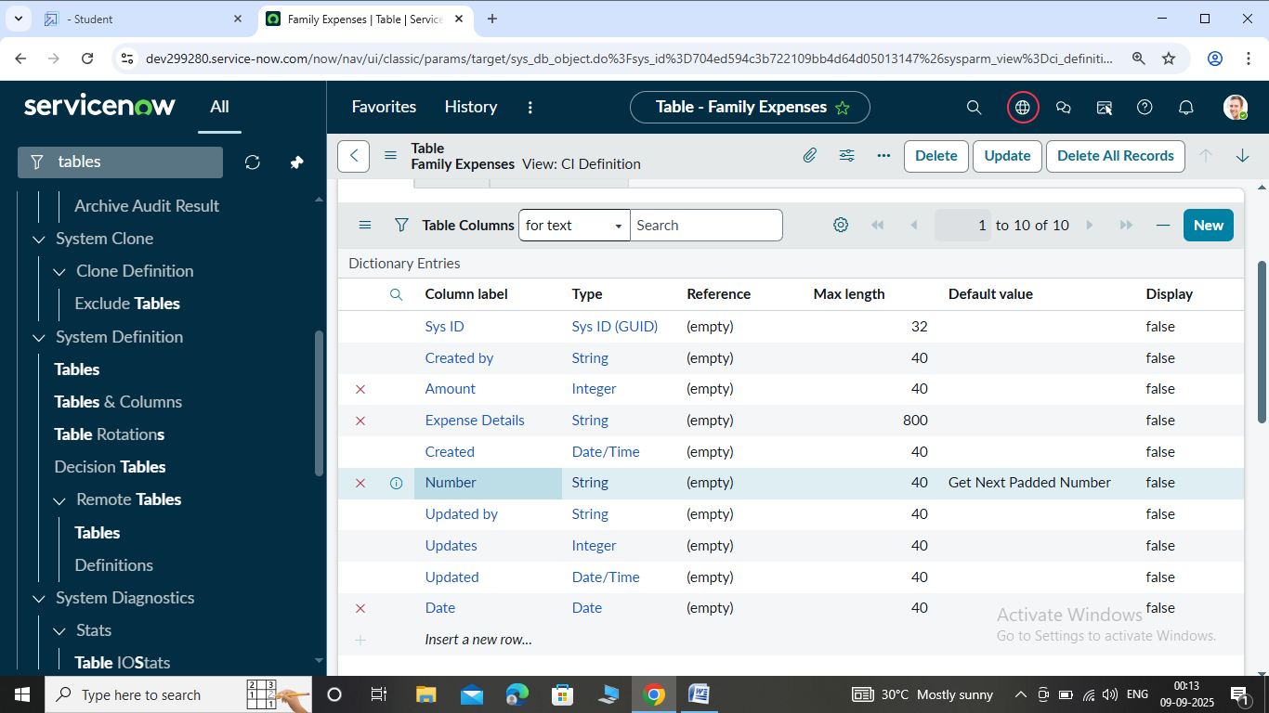

Making “Number” field an auto number:

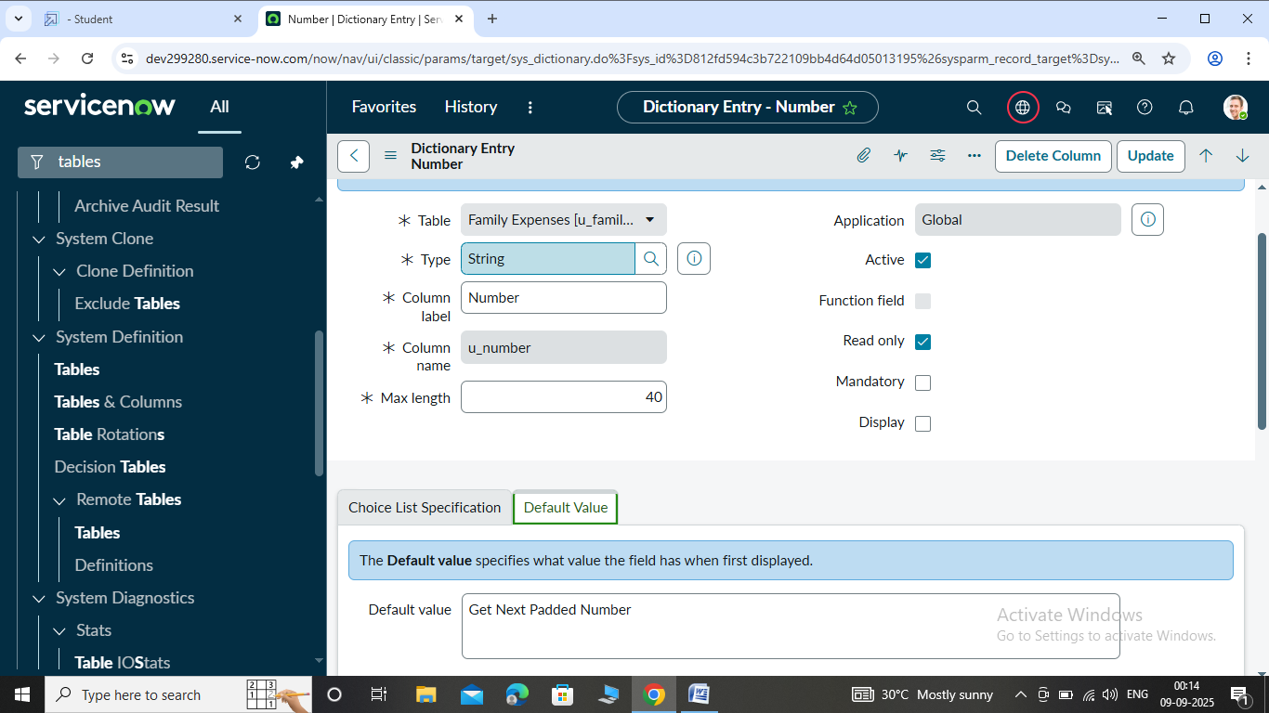

Configure the form:

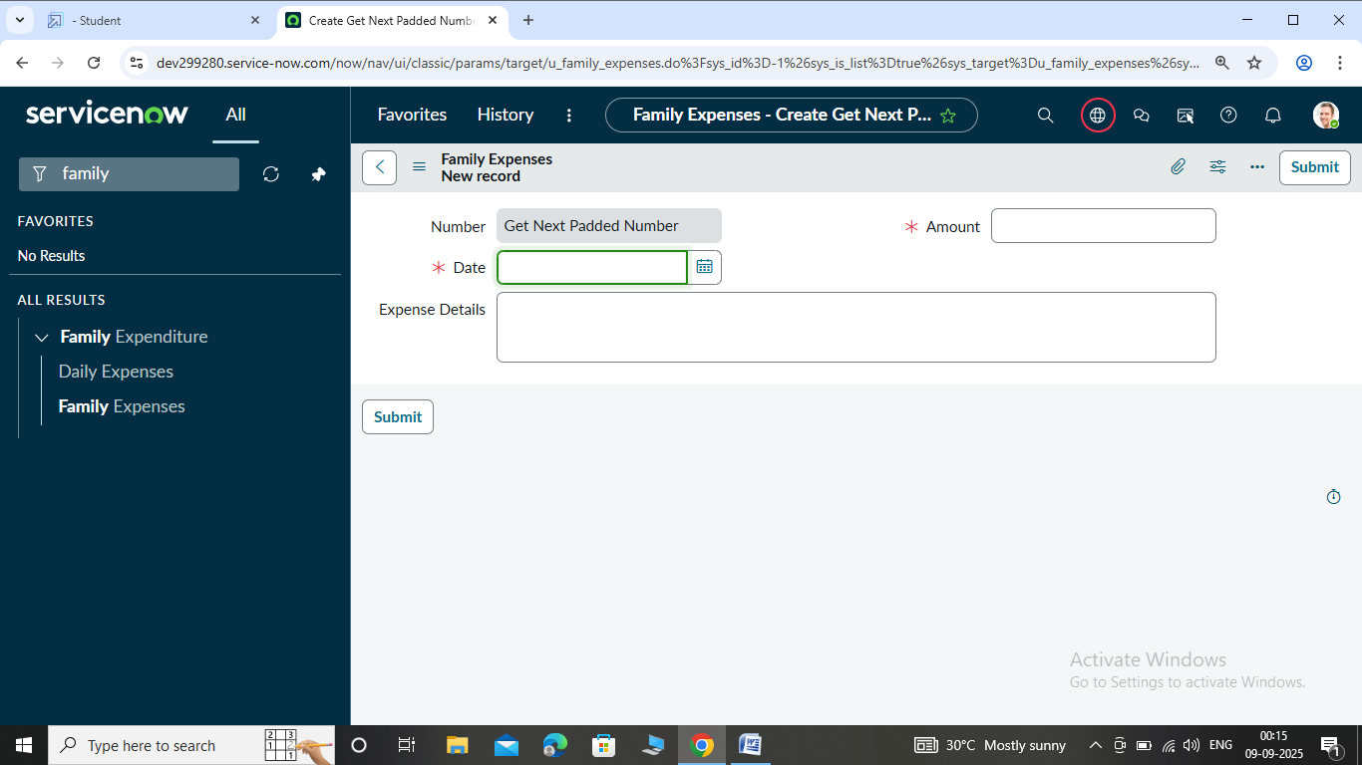

**Daily Expense Table:**

Creation of Daily Expenses table:

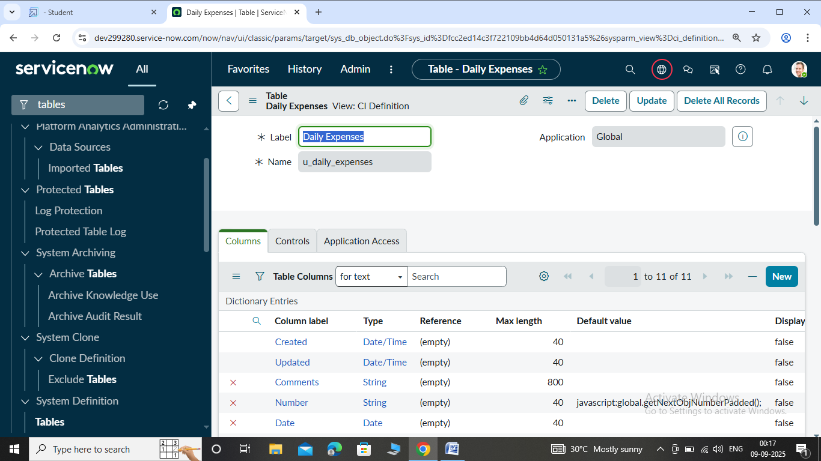

Creation of Columns:

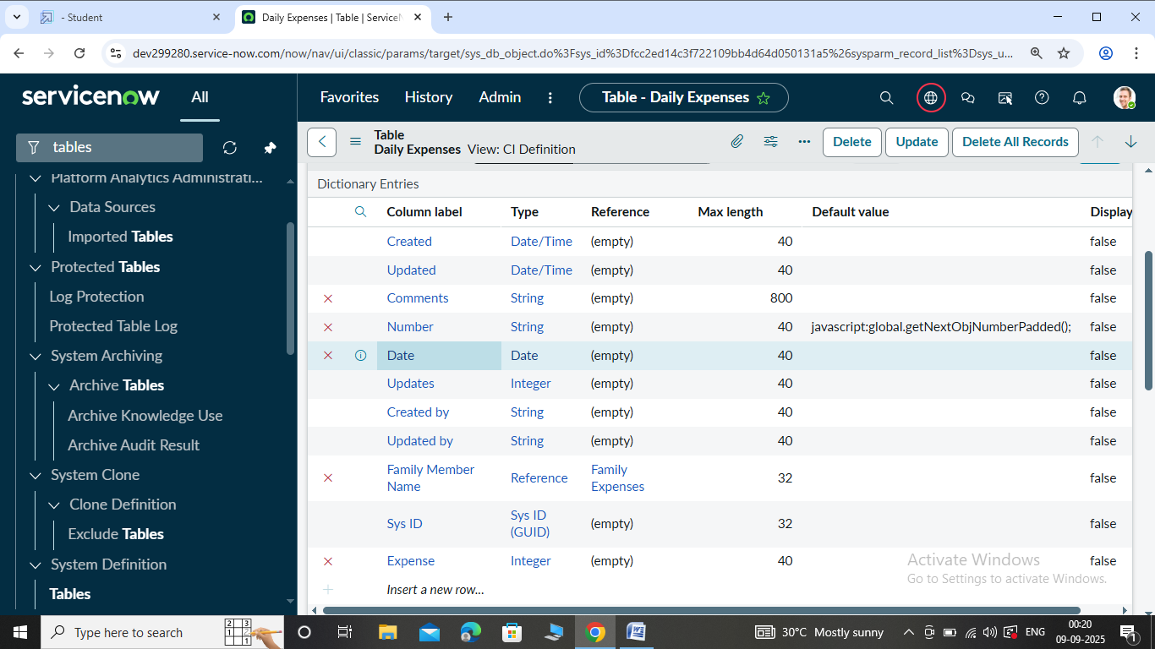

Making Number field an auto number:

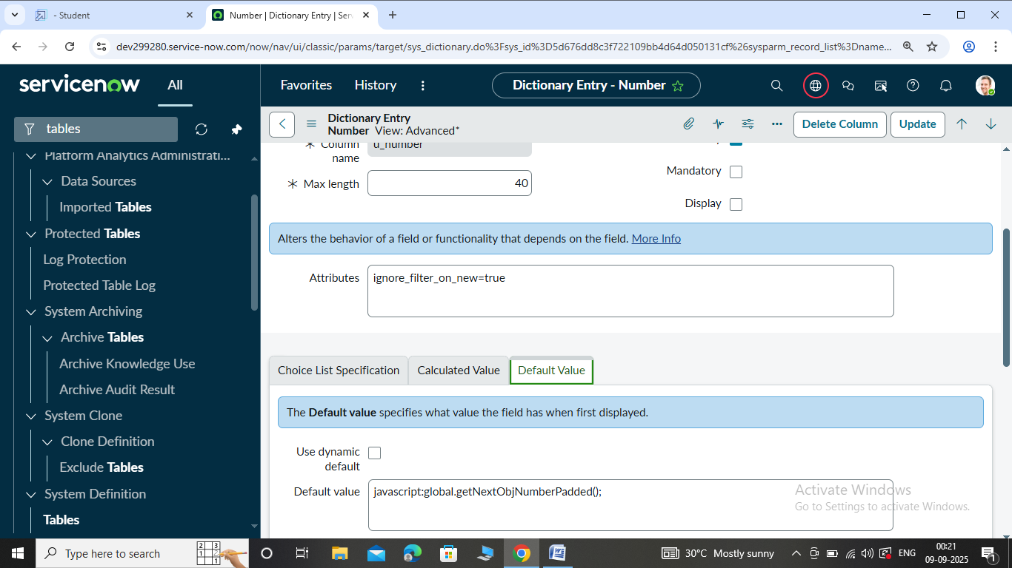

Configure the Form:

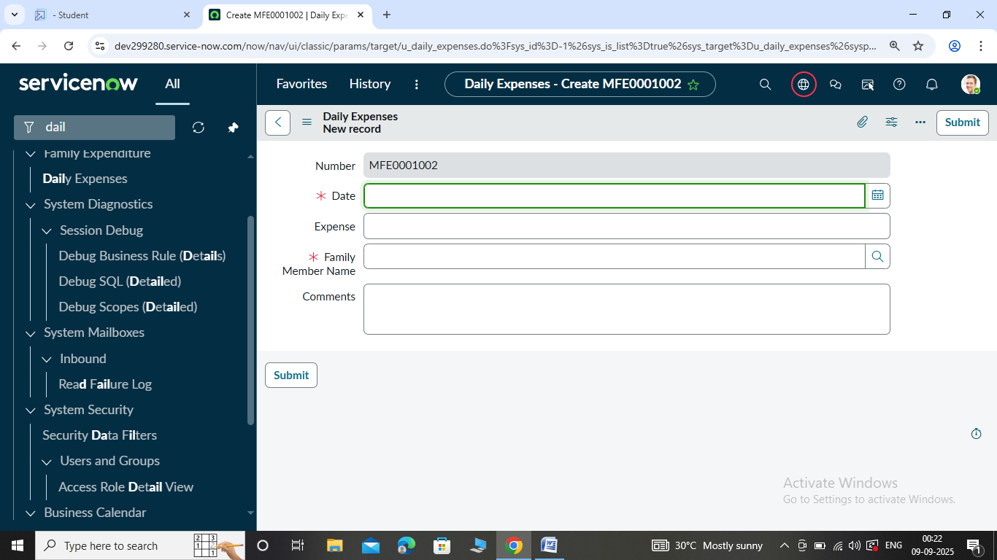

Creation of relationship between Family Expenses & Daily Expenses Table:

## 

Configuring Related list on Family Expenses:

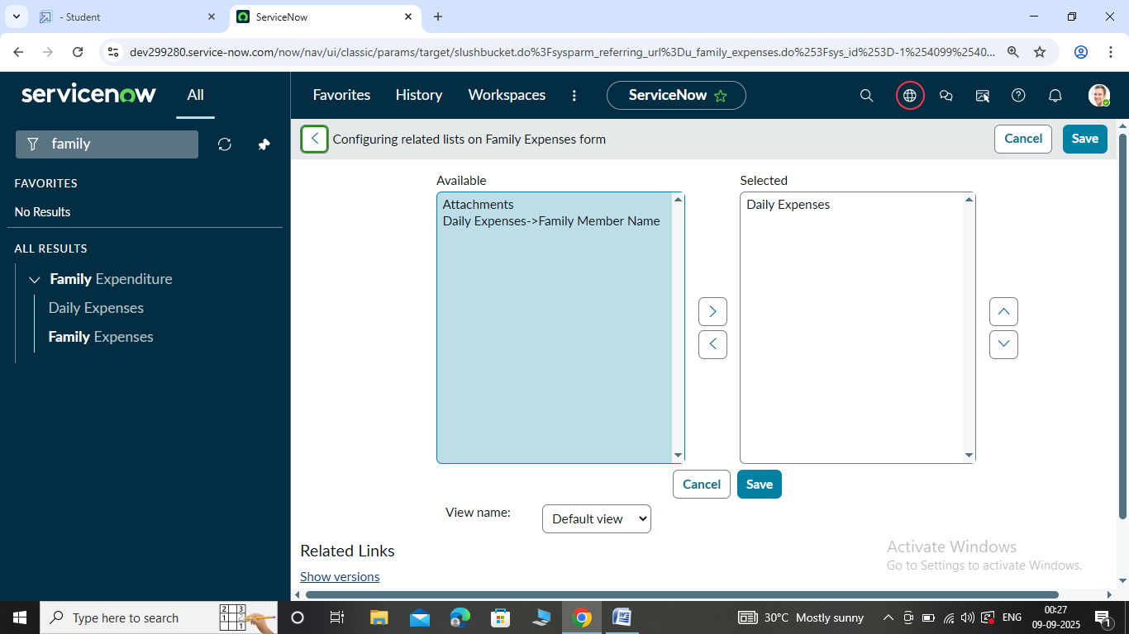

Creation of Business Rules:

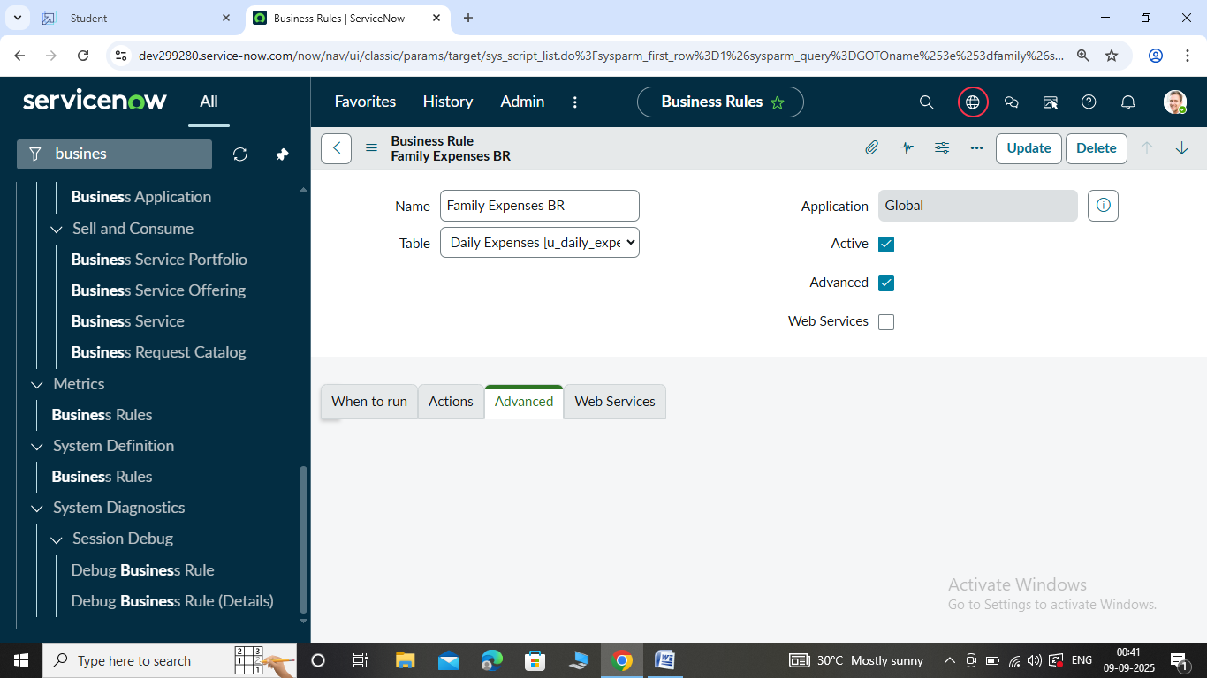

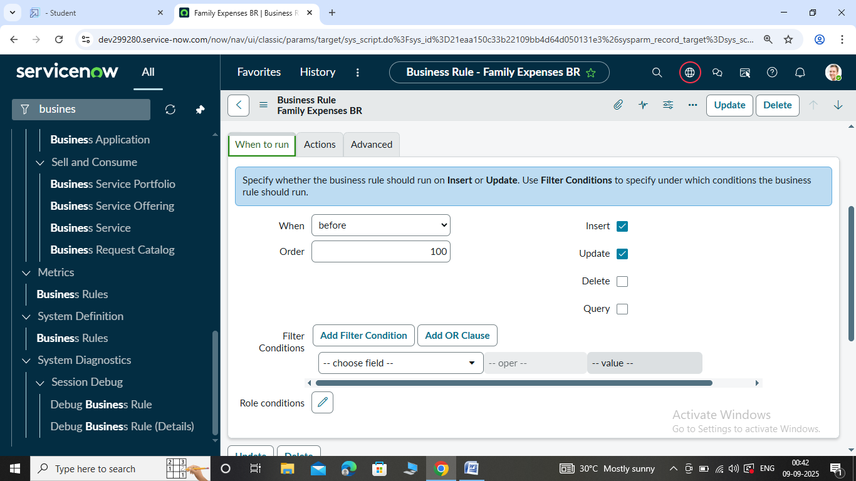

Configure the Relationship:

